**FUNDAMENTAL OF PROGRAMMING**

**HOME TASK 5**

**SUBMITTED TO SIR AFFAN TARIQ**

**SUBMITTED BY ABDUL MANAN**

**QALAM : 462449**

**TASK 1**

**#include <iostream>**

**using namespace std;**

**int main(){**

**int A, B, lcm, hcf, big;**

**cout << "Enter 1st number: ";**

**cin >> A;**

**cout << "Enter 2nd number: ";**

**cin >> B;**

**if (A >= B){**

**big = A; }**

**else {**

**big = B;}**

**for (int i = 1 ; i <= big; ++i){**

**if (A% i == 0 && B % i == 0){**

**if (i != 1){**

**hcf = i; }**

**if (i == 1){**

**hcf = 1;}**

**}**

**}**

**lcm = ((A * B) / hcf);**

**cout << "LCM: " << lcm;**

**return 0;**

**}**

**TASK 2**

**#include <iostream>**

**using namespace std;**

**int main() {**

**double a, d, n,i,sum;**

**cout <<"Enter first term ";**

**cin >> a;**

**cout <<"Enter difference ";**

**cin >> d;**

**cout <<"Enter the number of terms ";**

**cin >> n;**

**cout<<endl;**

**for (int i = a; i <= (a + (n - 1) * d); i = i + d){**

**sum = sum + i;**

**cout << i << "\t";**

**}**

**return 0;**

**}**

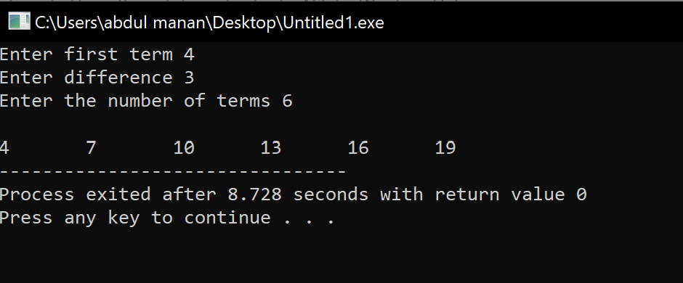

**TASK 3**

**#include <iostream>**

**using namespace std;**

**int main() {**

**int mid_row;**

**cout << "Enter the lines till half diamond: ";**

**cin >> mid_row;**

**cout << endl;**

**for (int i = 1; i <= mid_row; ++i){**

**for (int j = 1; j <= (mid_row - i) ; ++j){**

**cout << " "; }**

**for (int k = 1; k <= (2 * i - 1) ; ++k){**

**cout << "*"; }**

**cout << endl; }**

**for (int i = mid_row - 1; i >= 1; --i){**

**for (int j = 1; j <= (mid_row - i) ; ++j){**

**cout << " "; }**

**for (int k = 1; k <= (2 * i - 1) ; ++k){**

**cout << "*"; }**

**cout << endl; }**

**return 0;**

**}**

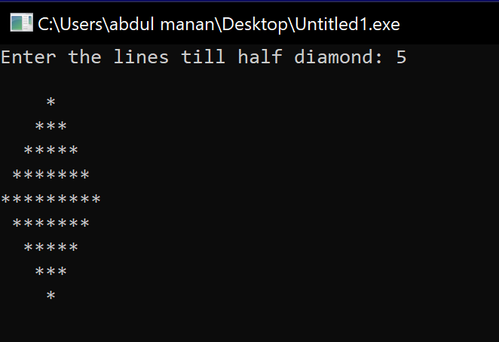

**TASK4**

**#include <iostream>**

**using namespace std;**

**int main()**

**{**

**int x, r, q, m = 1, b = 0;**

**cout << "Enter the number: ";**

**cin >> x;**

**while (x != 0){**

**q= x / 2;**

**r= x % 2;**

**b = b + ( r * m);**

**x = q;**

**m= m * 10;**

**}**

**cout << b;**

**return 0;**

**}**

